**Exhaustive Analysis of Indian Agriculture Using Power BI**

Week-1 Project Submission

Name: Bathula Anjaneyulu

AICTE ID: STU64d662589cd991691771480

**STEP-1**

<https://www.microsoft.com/en-us/download/details.aspx?id=58494>

**1. Download Power BI Desktop:**

* **From the Microsoft Store:**
  + Open the [Power BI Desktop page on the Microsoft Store](https://www.microsoft.com/en-us/p/power-bi-desktop/9ntxr16hnw1t).
  + Click on the "Get" or "Install" button to download and install the application directly.
* **Direct Download:**
  + Visit the [Power BI Desktop Download Center](https://www.microsoft.com/en-us/download/details.aspx?id=58494).
  + Click on the "Download" button.
  + Choose the appropriate version (32-bit or 64-bit) that matches your Windows operating system.
  + Run the downloaded installer and follow the on-screen instructions to complete the installation.

**2. Install Power BI Desktop:**

* After downloading, locate the installer file (usually in your "Downloads" folder).
* Double-click the installer to run it.
* Follow the installation prompts to complete the setup.

**STEP-2**

* Click on Power BI Desktop to open it.
* The application will start loading and display the Power BI splash screen.

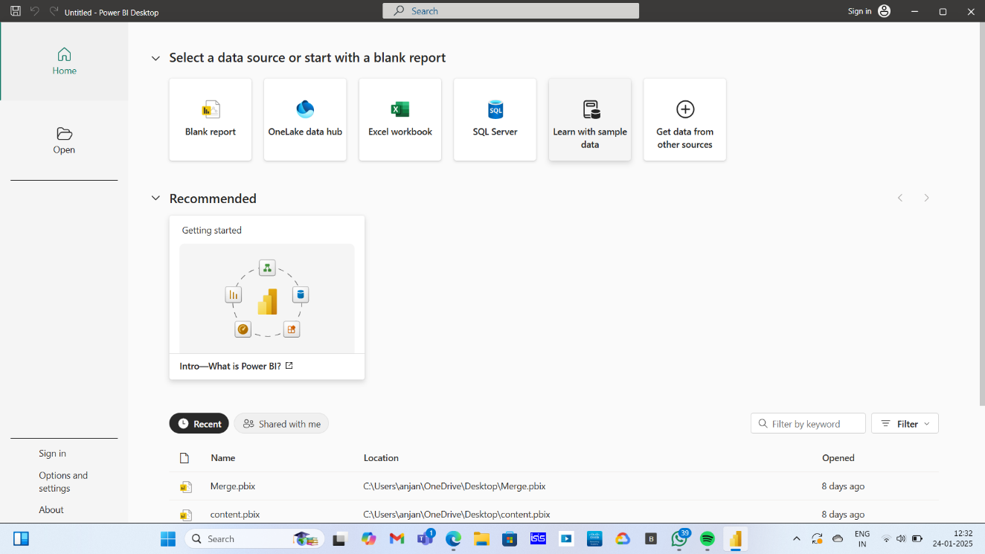

* Now click on Blank Report

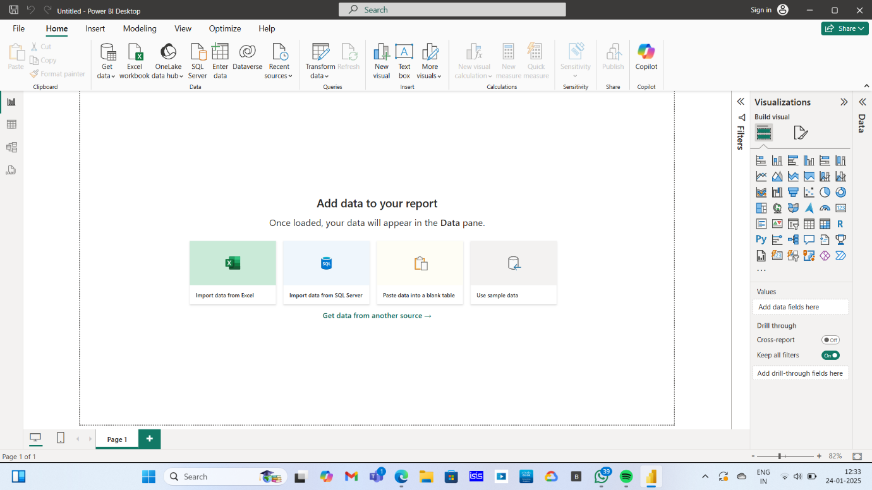

* + Once it’s open, you’ll see the **Power BI interface**, with options to load data, create reports, or start with templates.

**STEP-3**



**Download the CSV File**

* Save the file in an easily accessible location on your computer (e.g., Desktop or Downloads folder).

**STEP-4**

* On the Home tab of the Power BI ribbon, click "Get Data".
* Select "Text/CSV" from the list of data sources.
* Browse to the location of your CSV file and select it. Click "Open".

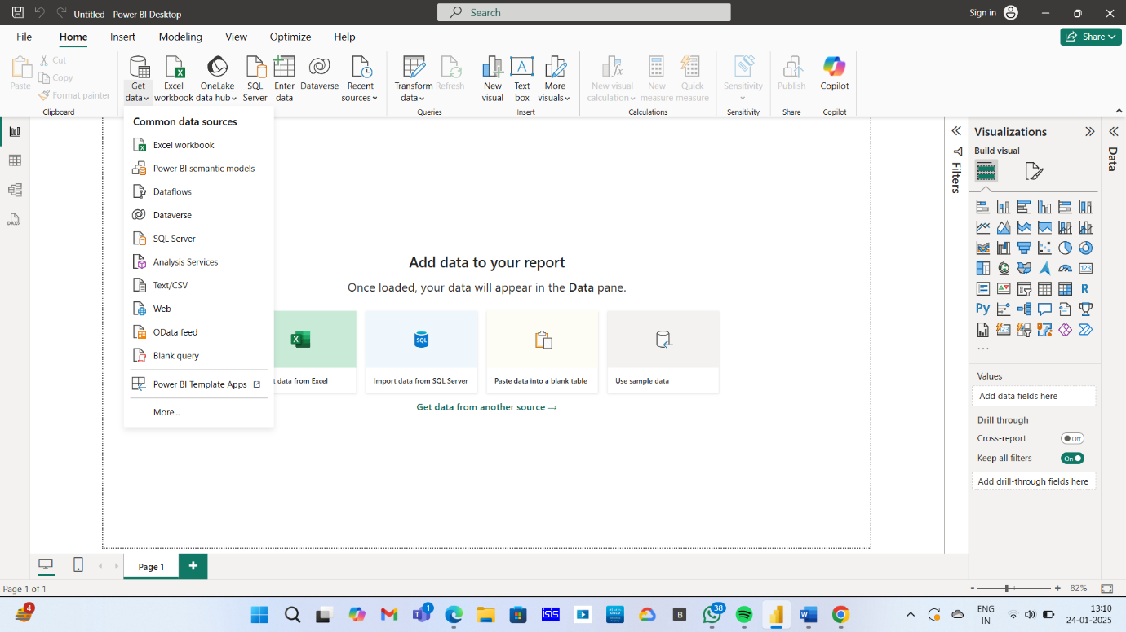

**STEP-5**

* Power BI will display a preview of your CSV file.
* Review the data to ensure it is correctly loaded.
* Click "Load" to import the data into Power BI.

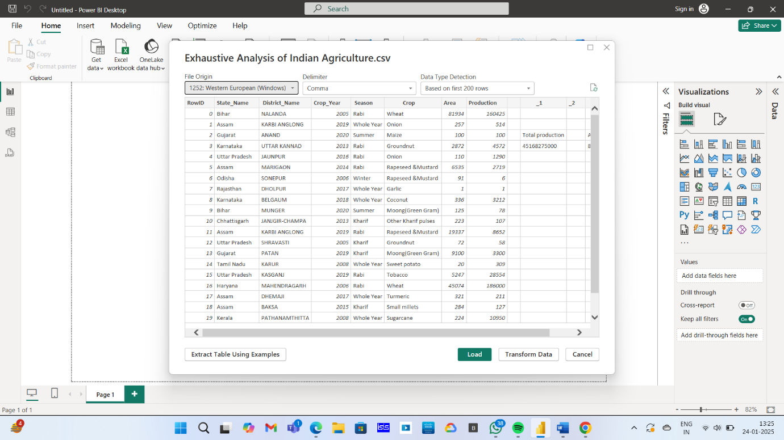

* Once you click "Load", Power BI will process the file and import the data.
* You will see the dataset listed under the "Fields" pane on the right side of the Power BI window.

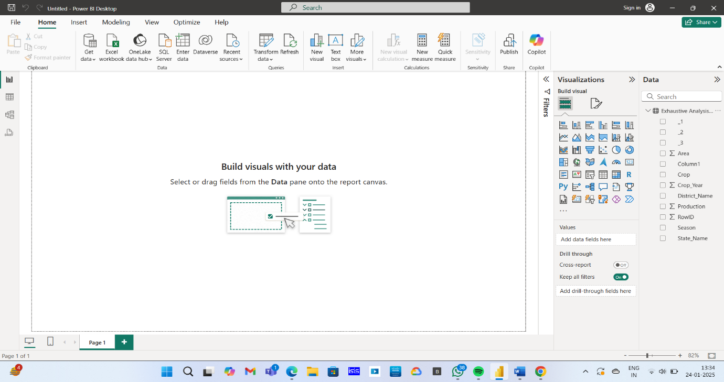

After importing data, Power BI provides three main views for working with your dataset:

**1.Report View (Default View)**

* **What It Is**: The Report View is the main area where you create visualizations (charts, graphs, tables, etc.).
* **How to Use It**:
  + Located in the left sidebar, represented by a 📊 **chart icon**.
  + Drag and drop fields from the **Fields pane** into the **Canvas** to create visualizations.
  + Use the **Visualizations pane** to customize charts, apply filters, and format data.
* **Purpose**: Helps in designing dashboards and interactive reports.

**2.Data (Table) View**

* **What It Is**: This view allows you to see the raw imported data in a table format.
* **How to Use It**:
  + Click on the 📋 **table icon** in the left sidebar.
  + View all rows and columns from your CSV file in tabular form.
  + You can check data types, rename columns, or verify data accuracy.
* **Purpose**: Used to inspect raw data before creating reports.

**3.Model View**

* **What It Is**: The Model View shows the relationships between different tables in your dataset.
* **How to Use It**:
  + Click on the 🔗 **relationship icon** in the left sidebar.
  + If you have multiple datasets, Power BI will try to detect relationships automatically.
  + You can manually create relationships by dragging fields between tables.
* **Purpose**: Helps in setting up **data relationships** for complex reports.

**STEP-6**

* Click on **"Transform Data"** in the **Home** tab of Power BI.
* This opens the **Power Query Editor**, where you can modify your data before using it in reports.

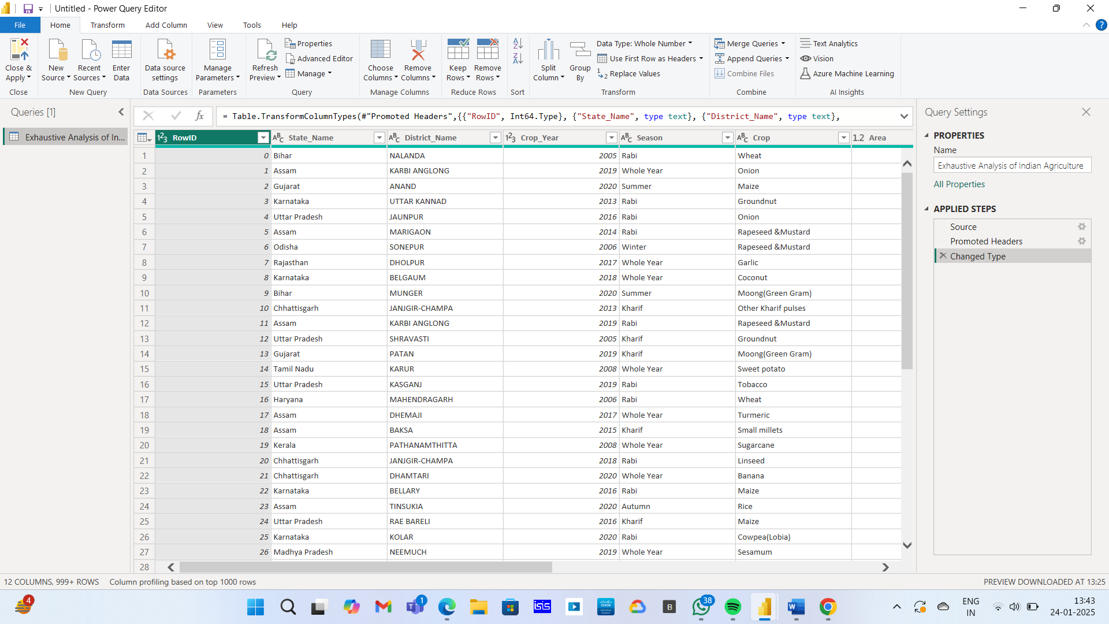

**1.Remove Unnecessary Columns**

* Select the columns you don’t need.
* Click **"Remove Columns"** in the **Home** tab.

**2.Rename Columns for Better Readability**

* Double-click a column header to rename it.
* Alternatively, select the column and click **"Rename"** in the ribbon.

**3. Change Data Types**

* Ensure columns have the correct data type (e.g., Date, Text, Number).
* Select a column and choose the correct data type from the **Data Type dropdown** in the toolbar.

**4. Handle Missing or Null Values**

* Click on a column, then select **"Replace Values"** to fill missing values.
* Alternatively, use **"Remove Rows"** to delete incomplete data.

**5. Split or Merge Columns**

* Use **"Split Column"** (under the Transform tab) to separate values based on a delimiter (e.g., a comma in names).
* Use **"Merge Columns"** to combine multiple columns into one.

**6.Filter Rows (Keep or Remove Data)**

* Click on the **dropdown arrow** in a column header to apply filters (e.g., remove empty rows, filter by a specific value).

**7.Remove Duplicates**

* Select a column and click **"Remove Duplicates"** to eliminate repeated entries.

**STEP-7**

* Go to the "View" tab in the Power Query Editor.
* Click on "Column Quality" to enable it.

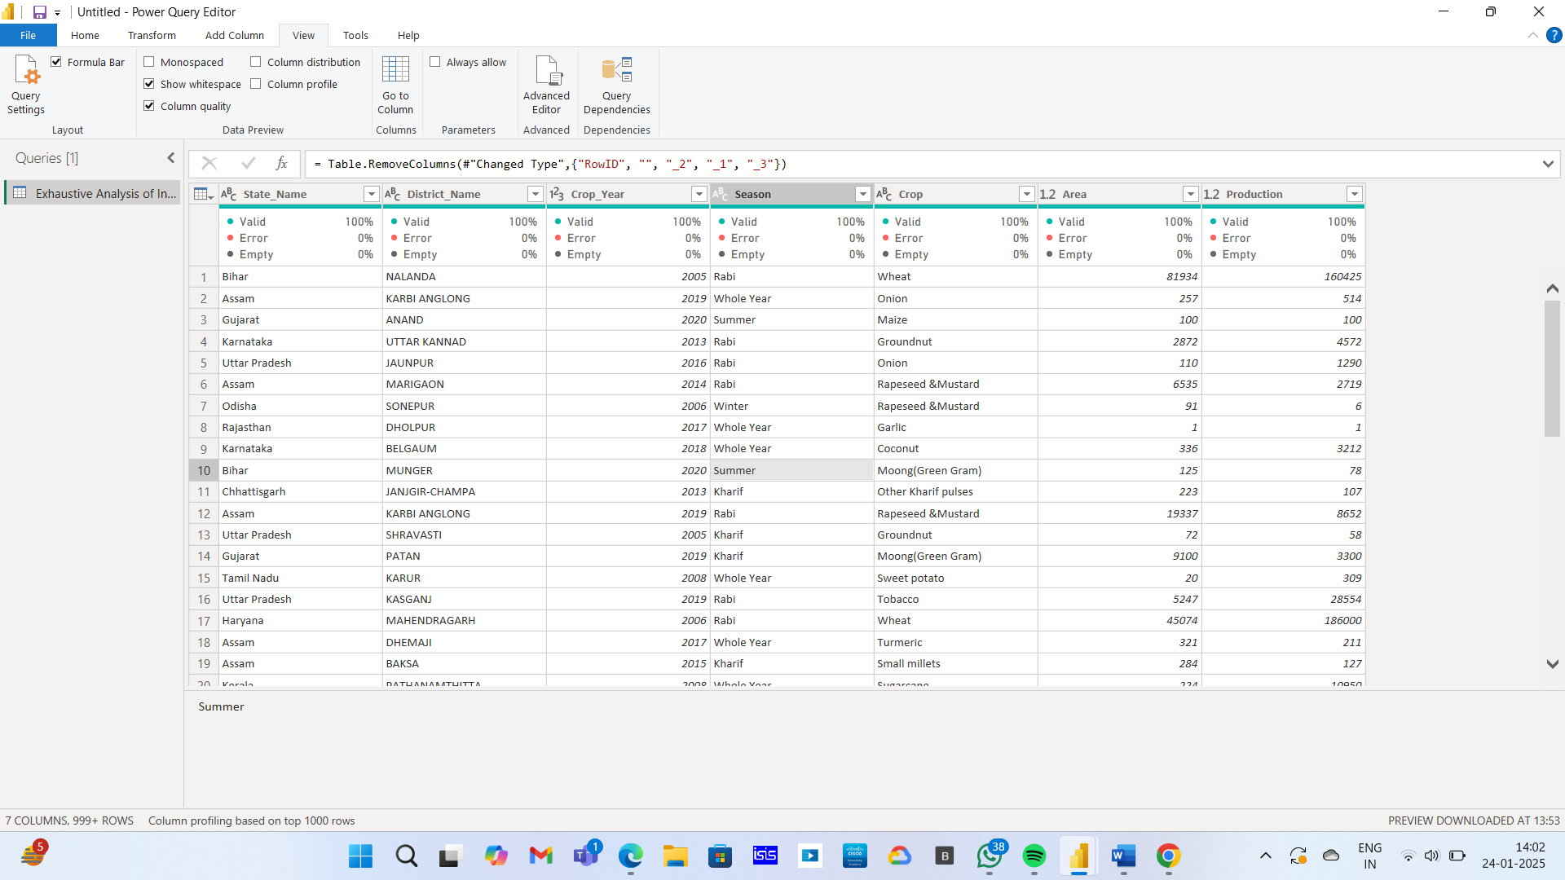

Once enabled, Power BI will show three quality indicators below each column:

* **Valid (% in Green)** → Percentage of values that are correctly formatted.
* **Error (% in Red)** → Percentage of values with errors (e.g., incorrect formats, missing data).
* **Empty (% in Gray)** → Percentage of blank or null values.

**Fix Data Quality Issues**

* **For Errors**: Click on the error percentage and replace or remove faulty data.
* **For Empty Values**: Fill in missing data using **"Replace Values"** or remove them.
* **For Incorrect Data Types**: Change column data types to ensure accuracy.

**STEP-8**

**Apply and Save Changes**

* After reviewing and fixing data quality issues, click "Close & Apply" to return to Power BI Desktop.